### Part e - Vertex AI: Custom training job and prediction using managed datasets

Using this codelab, we created a custom training pipeline and deployed the model to an endpoint for inferences. The model was trained on titanic dataset and the job was classification

1. Creating dataset

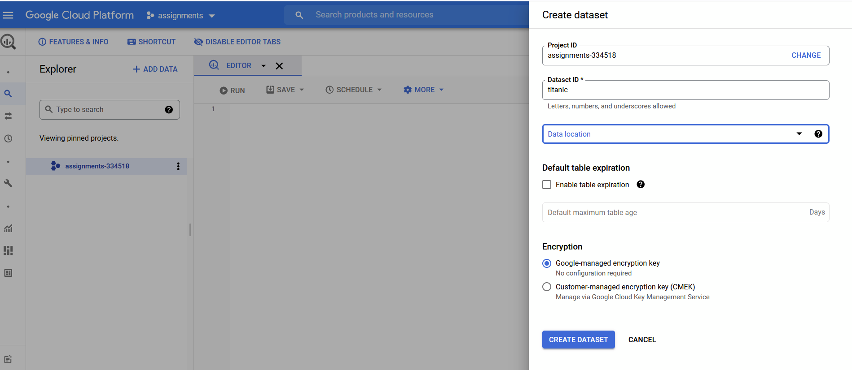

1. Uploading the titanic dataset as a table

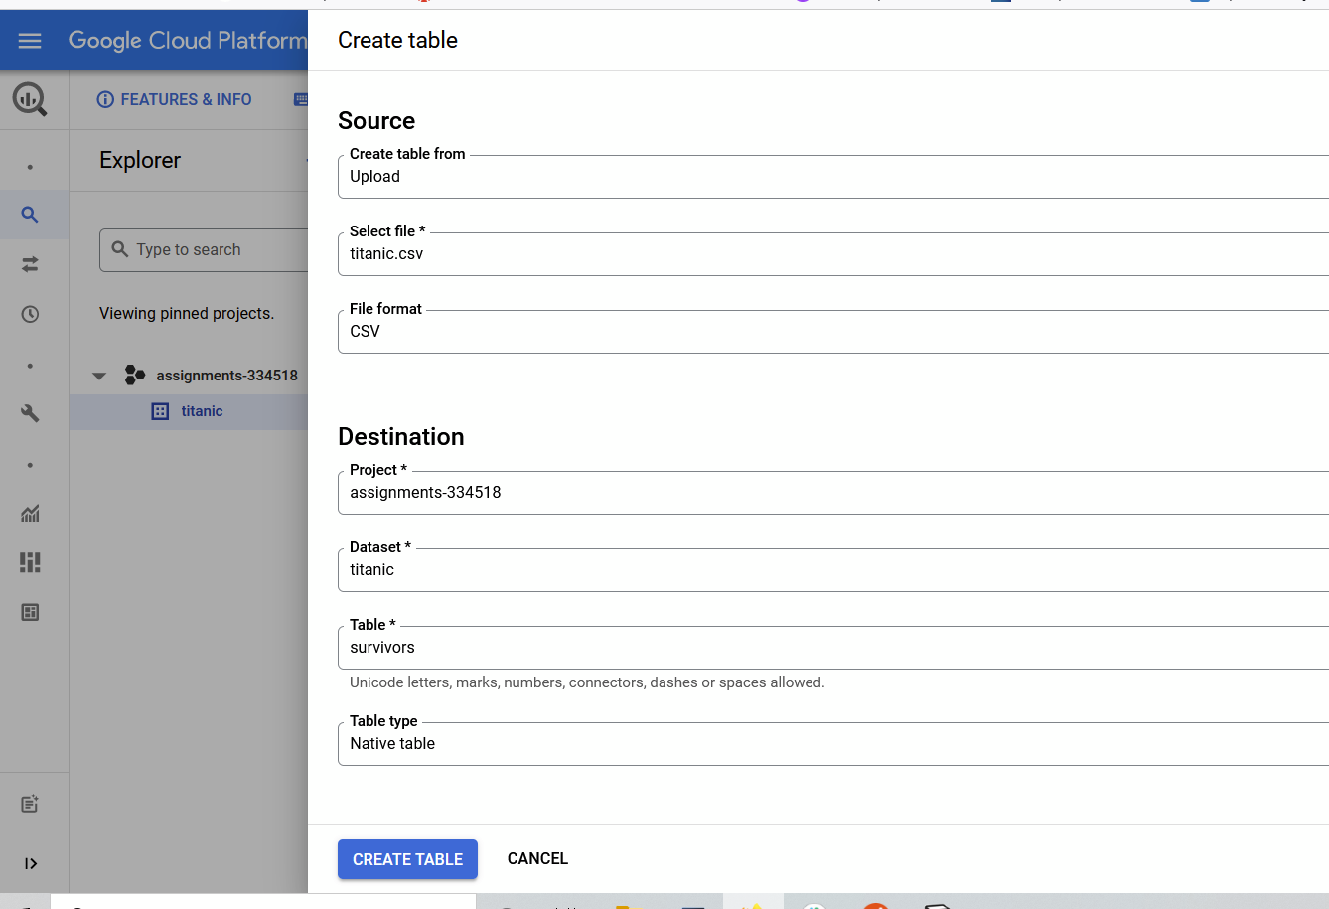

1. Creating titanic dataset on vertex AI

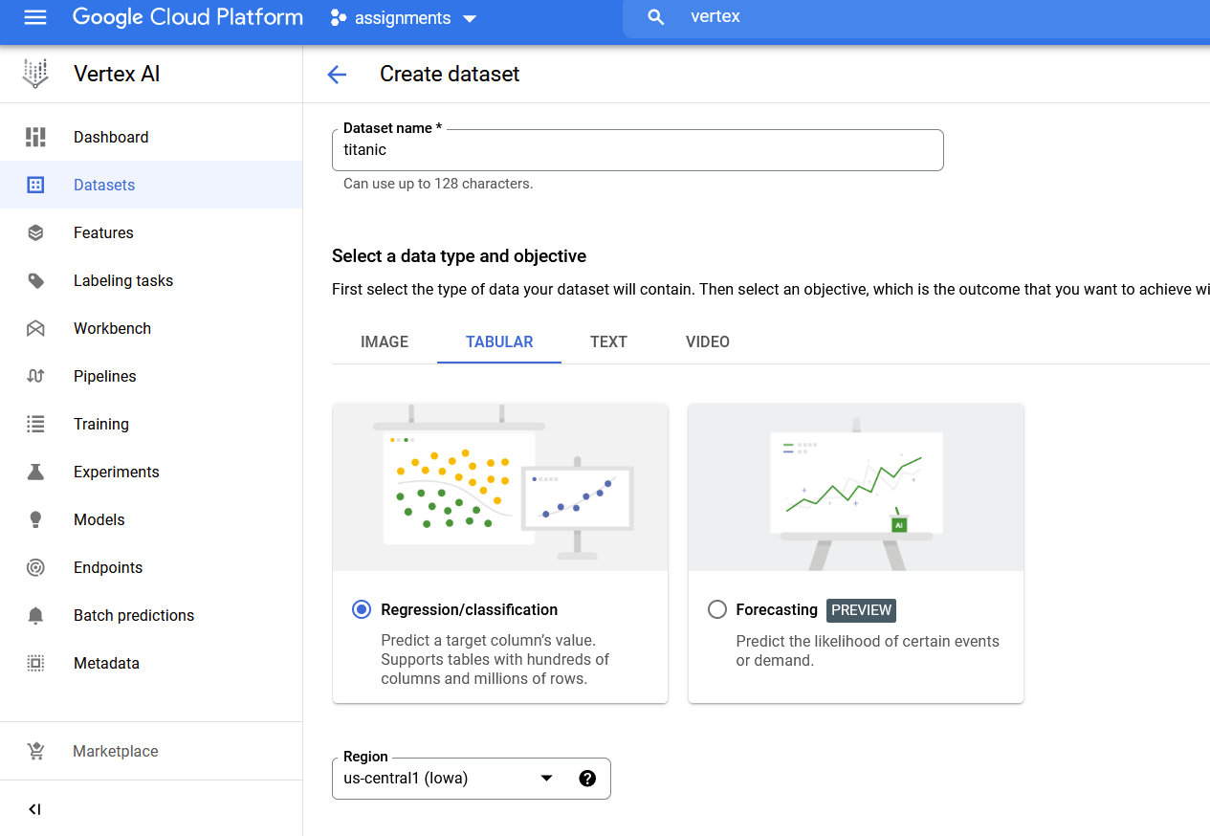

1. Adding data source to the vertex AI dataset from bigquery

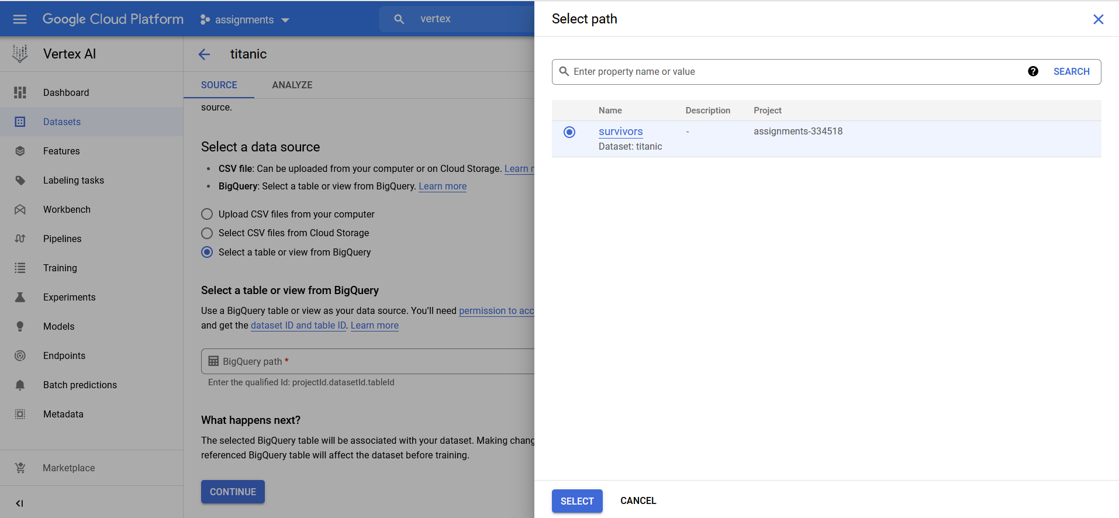

1. Generate statistics for the titanic dataset

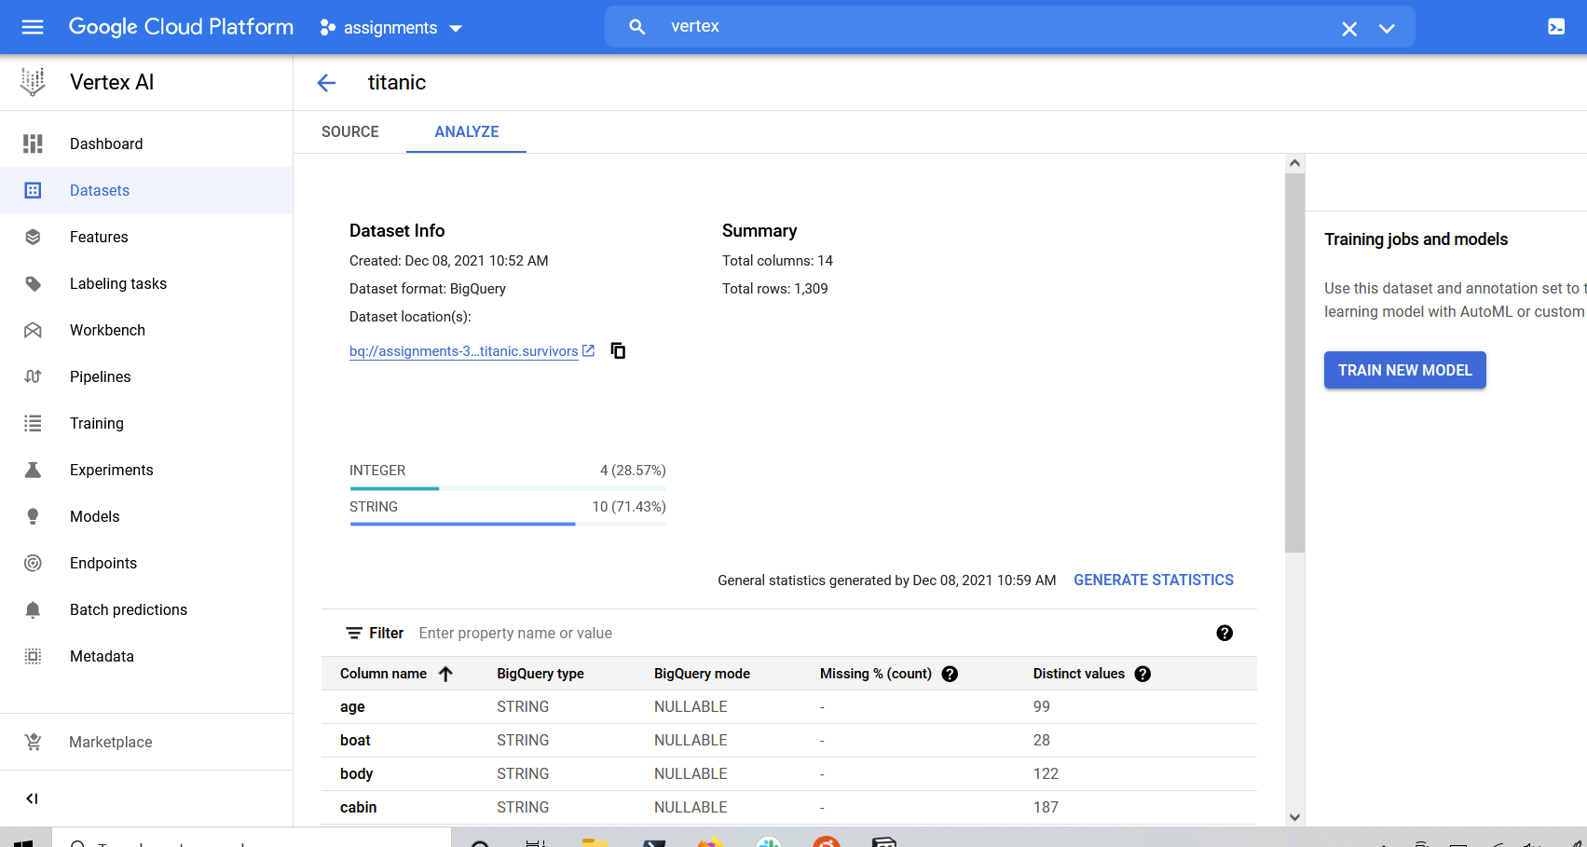

1. Creating notebook instance on vertex AI

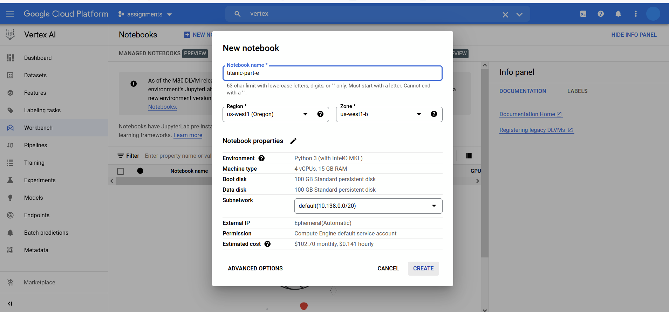

1. Creating a package to start building training assets

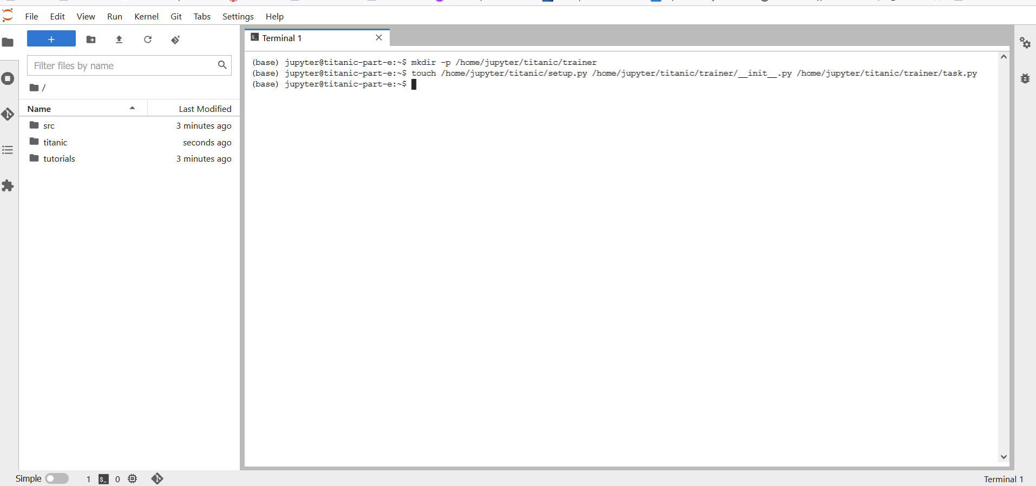

1. Editing task.py. This contains code to import titanic data from BigQuery, preprocessing data, training pipeline etc.

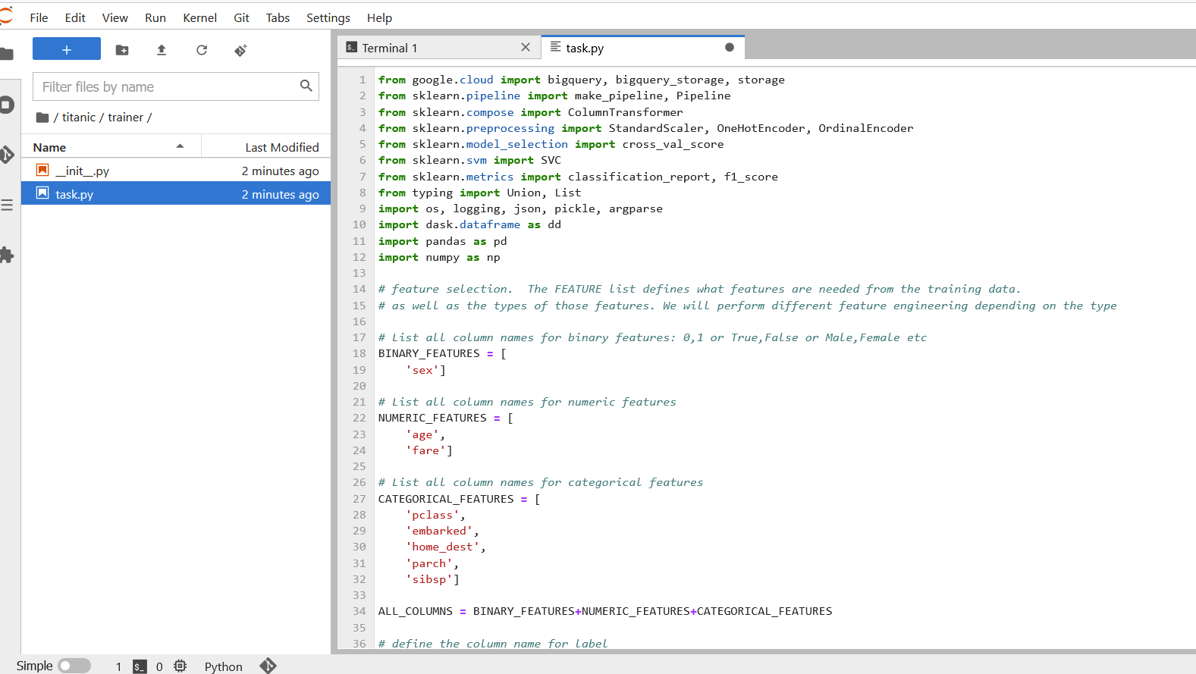

1. Checking to see if the training is happening with task.py

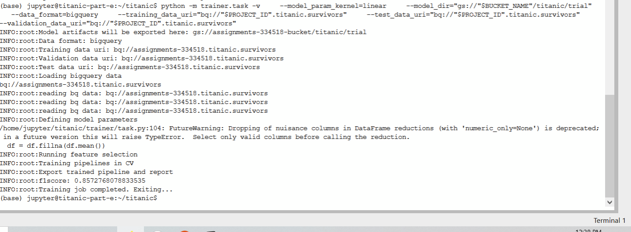

1. Created training package and exported to the appropriate bucket for training later

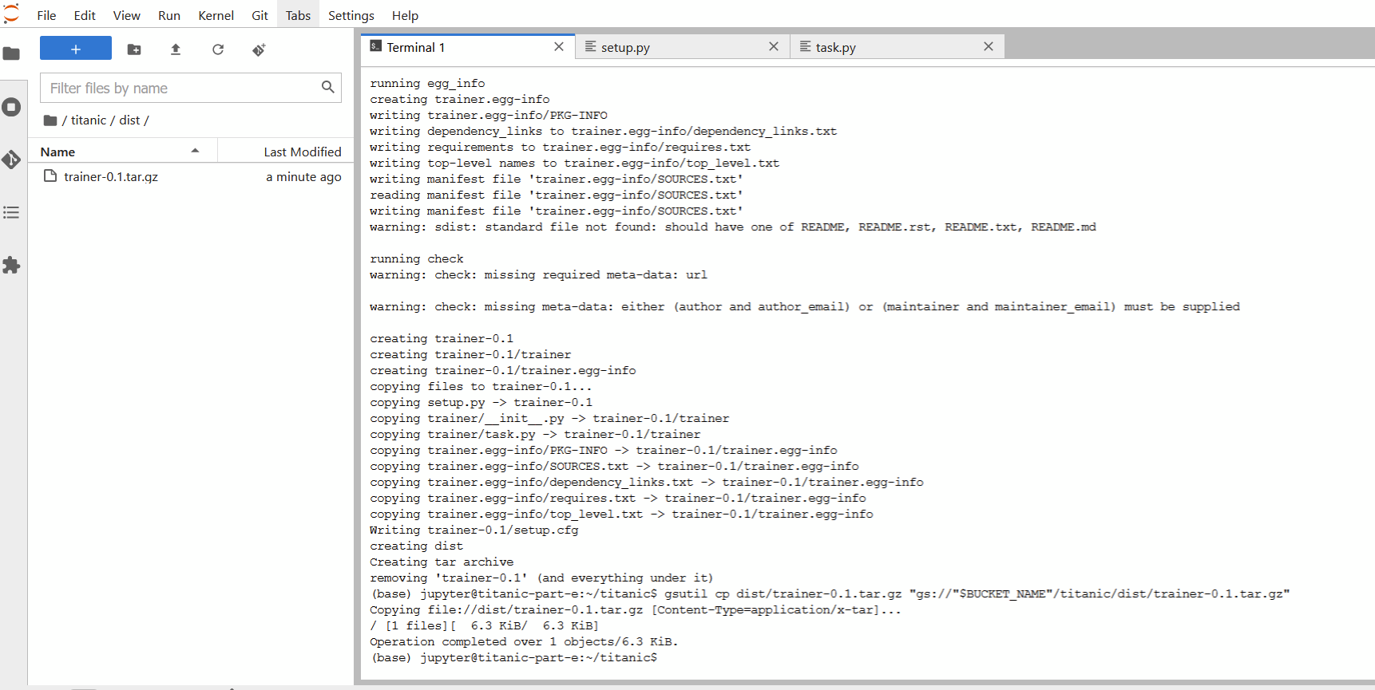

1. Starting the training from vertex GUI

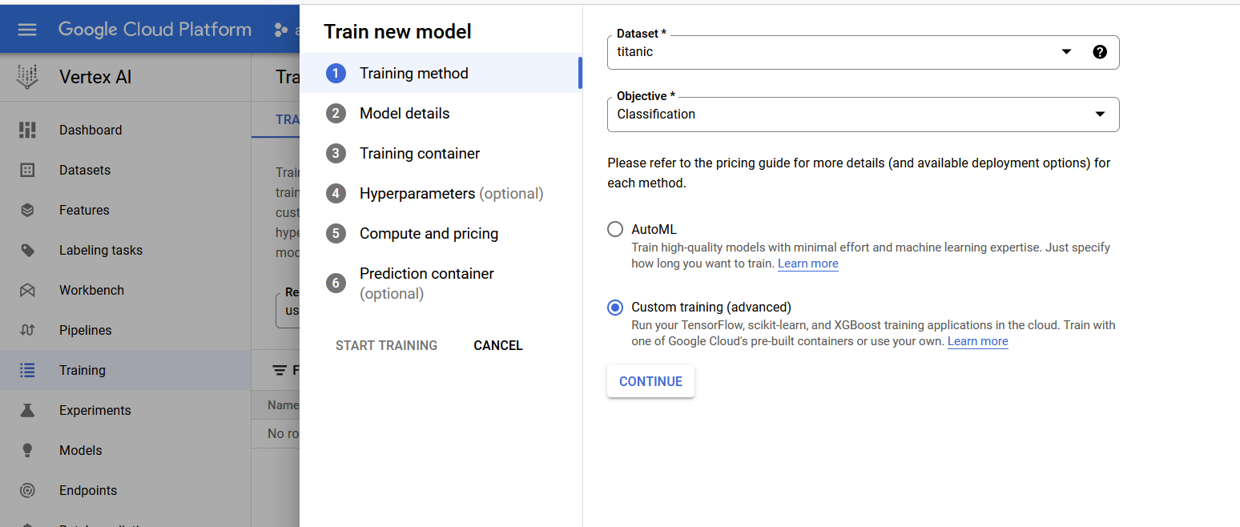

1. Starting training in vertex AI

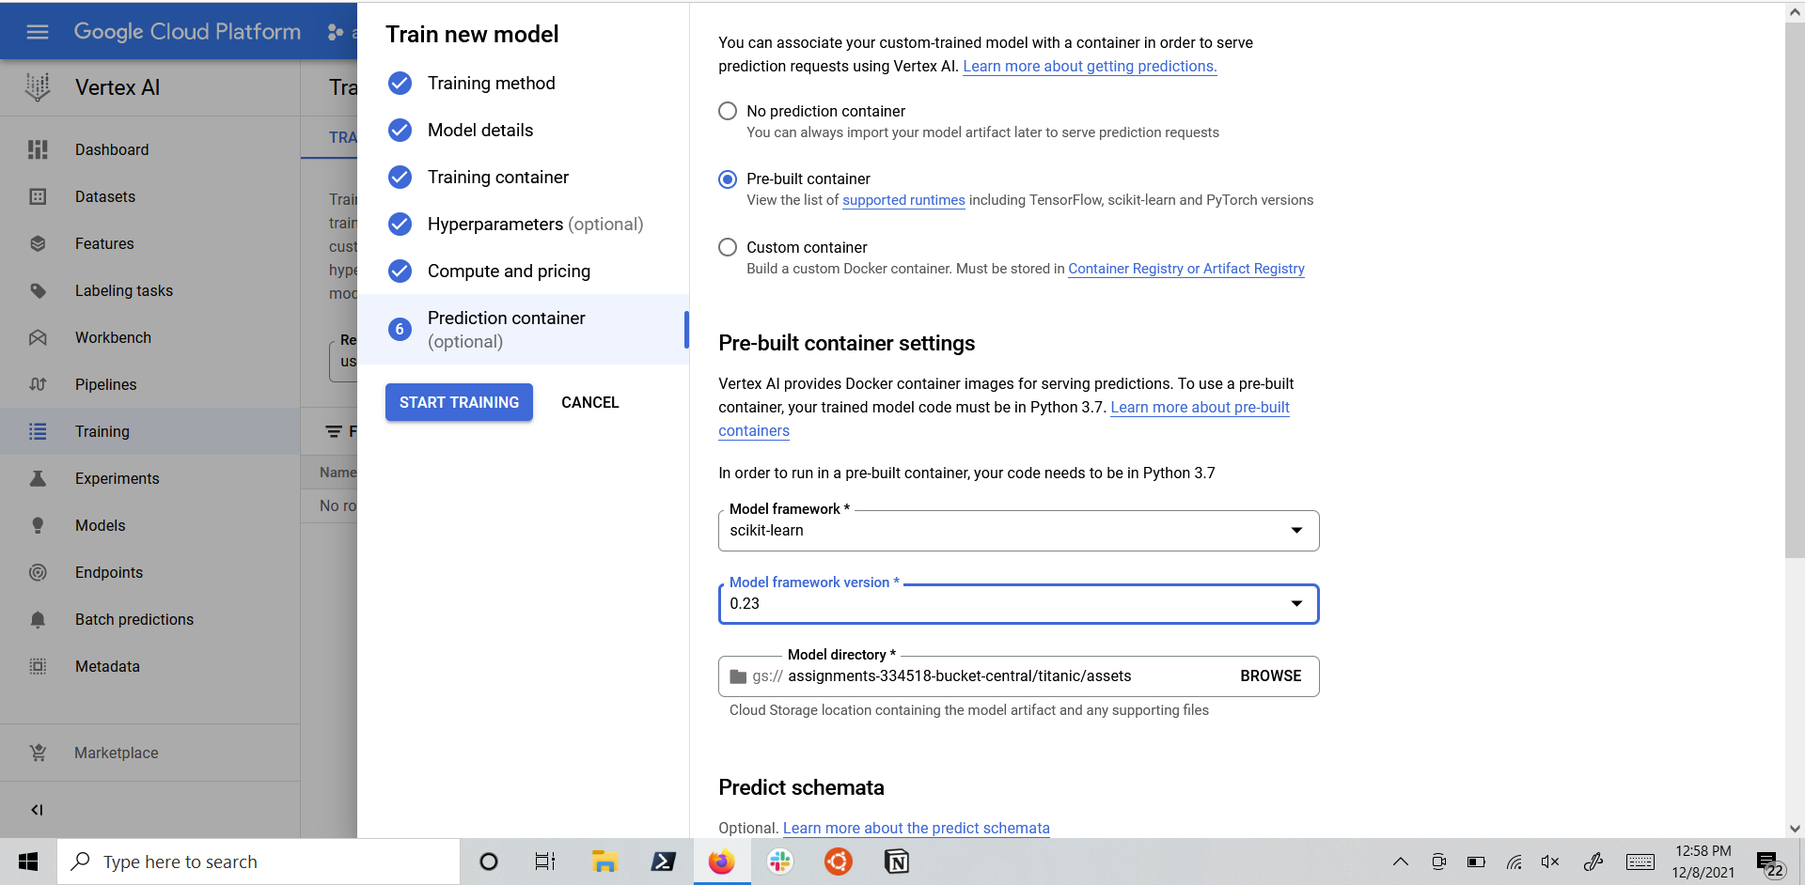

1. Completed training

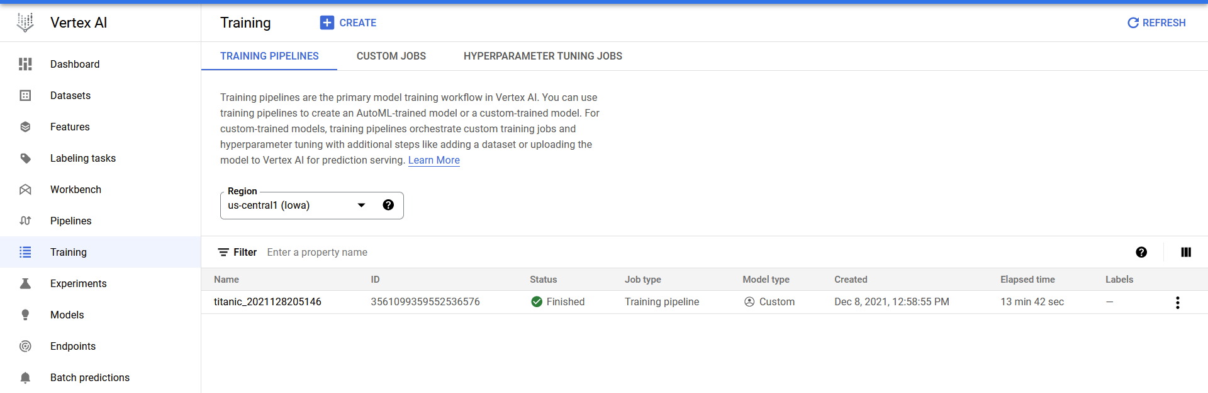

1. Evaluation report after training

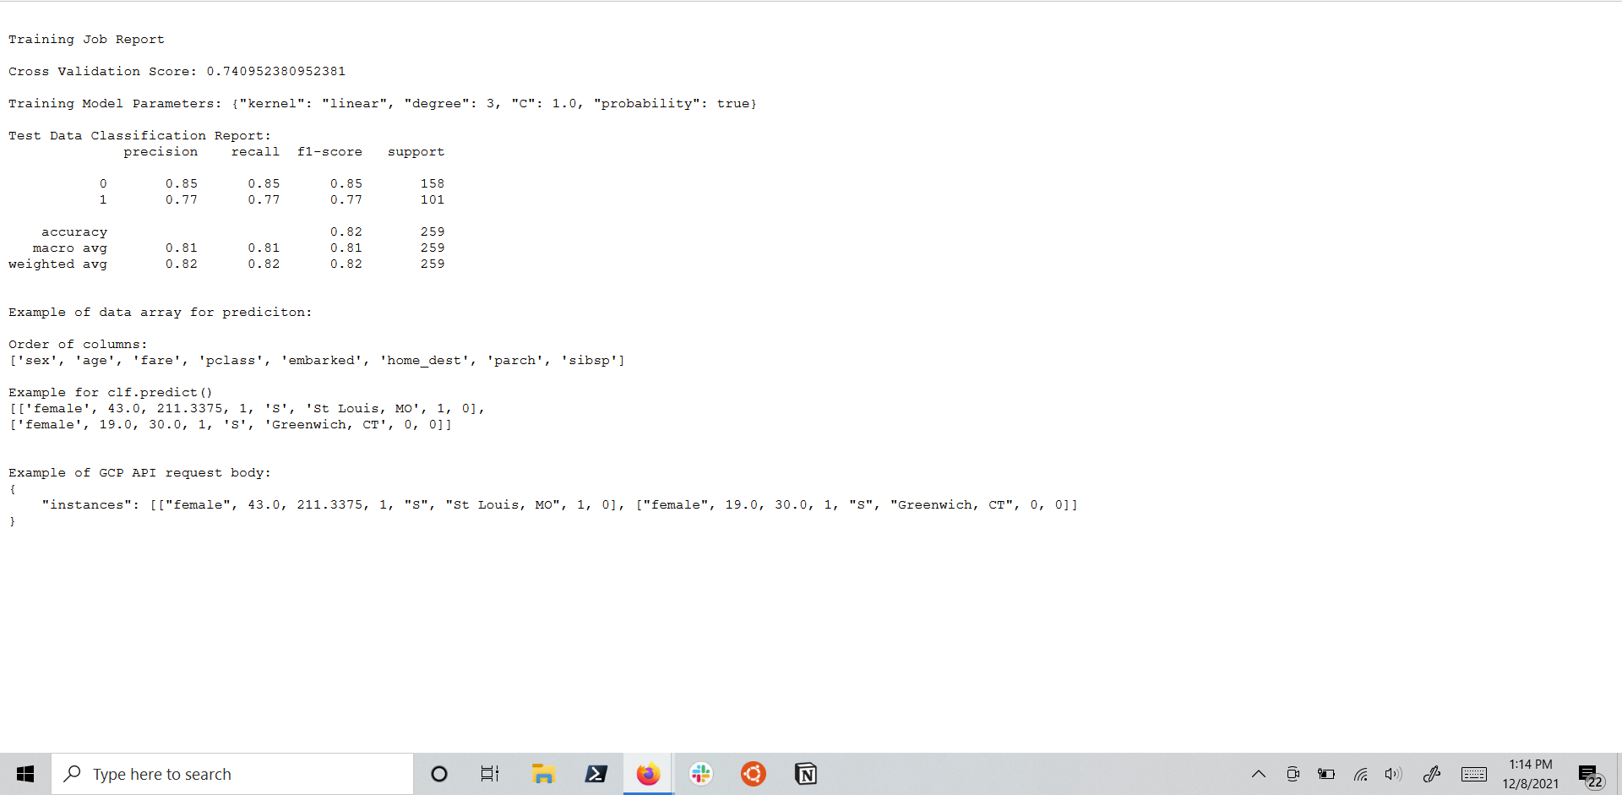

1. Deploying the model to an endpoint

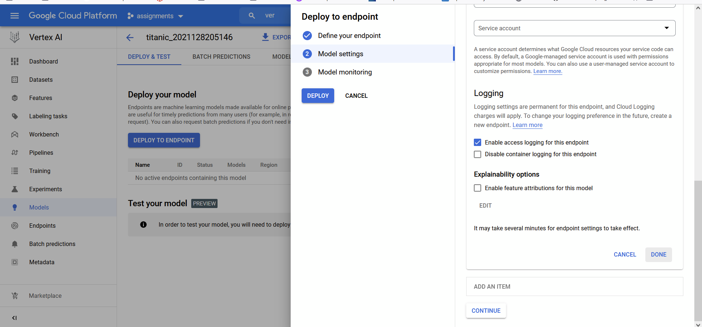

17. Deployed the model and prediction of the endpoint

